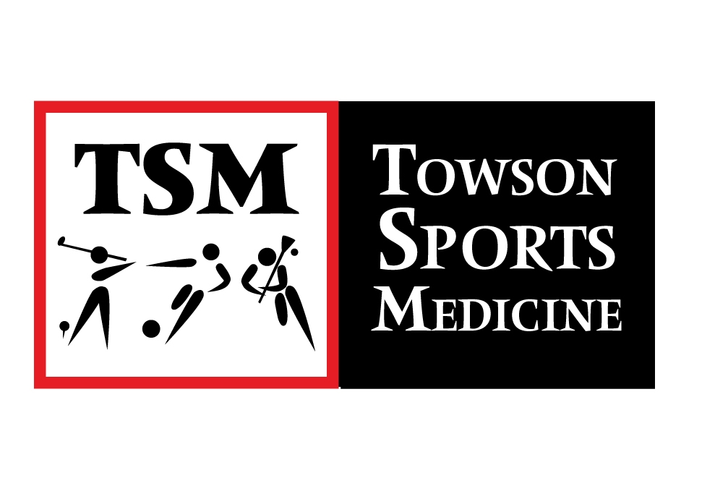
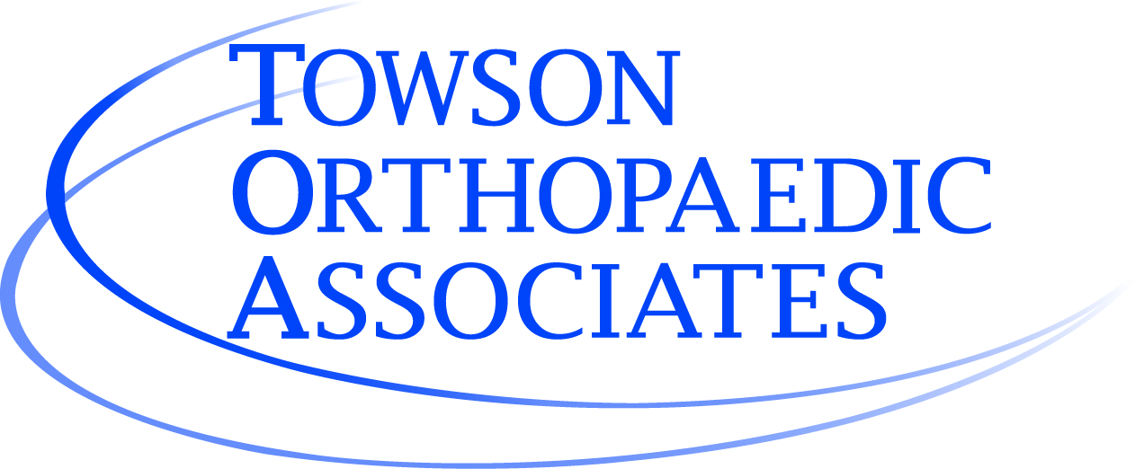
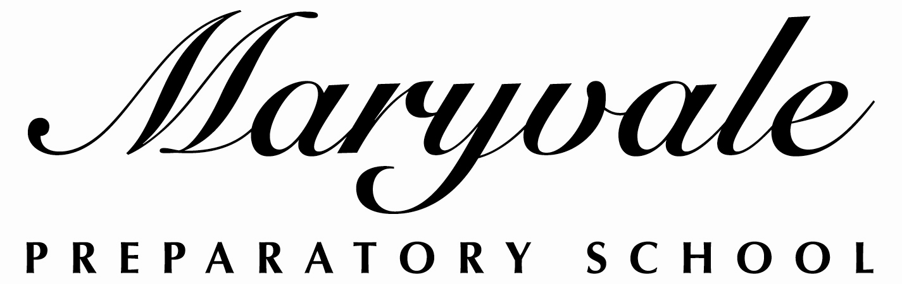

Student Name:

SPORTS CONCUSSION TESTING PROGRAM and RELEASE OF INFORMATION
I understand that pre-concussion baseline testing and post-concussion testing will be administered at my daughter’s school, and is a part of the procedure for guiding their return to sports participation after an injury.
Procedures
- There is no charge for the baseline testing conducted at the school.
- If my daughter sustains a concussion, typically this post-injury test will be re-administered by the athletic trainer within 1-3 days of the injury for comparison with the baseline test.
- In order to maintain quality of care post concussion, we strongly recommend your daughter follow up with Physicians at Towson Orthopedic Associates.
- Dr. Christopher Vaughan, Pediatric Neurophysiologist at Children’s National Medical Center will evaluate athlete’s post concussion data and determine return to play protocol with Certified Athletic Trainer.
- I may choose to consult with a Physician outside of Towson Orthopedic Associates at my own cost to assist my daughter’s recovery. The athletic trainer will work with this consultant to coordinate care.
- If I choose to have my daughter seen by a Physician outside of Towson Orthopedic Associates, I will incur a fee for release of medical information.
- Maryvale Preparatory School is not providing medical coverage or reimbursement for any testing, assessment, follow-up, or rehabilitation beyond the initial baseline ImPACT test.

Limitations on Use of Information
- I understand that the concussion baseline testing is designed only for concussion management and not as an IQ test and will not be used for educational planning or placement decisions.
- It is important to recognize that blows to the head can cause a variety of injuries other than concussions (e.g., neck injuries, more serious brain injuries). The Sports Concussion Program is designed for concussions only. You must see your doctor as soon as possible to address any other medical concerns.

Storage, Use of Information, Persons Authorized Access, and Confidentiality
- Maryvale Preparatory School will appropriately safeguard protected individually identifiable health information made available to or obtained by Maryvale from its students. Maryvale will comply with applicable legal requirements relating to protected Health Information.
- Test results will be stored confidentially on a password protected secure website.
- Only the following individuals will have access to the test results: School athletic trainer, consulting neuropsychologist/ team physician, and any physician designated by parent/guardian, upon receiving the release of information fee.
- Information about the student’s recovery may be provided to the school nurse, guidance counselor, school psychologist, and teachers to provide temporary health or academic support.
- The post-injury test results will be sent to me in writing and, if I request, to my designated physician.

Acknowledgement and Authorization – to be returned by August 18, 2014
I have read this document completely and I understand the terms and conditions set forth above under Procedures, Limitation on Use of Information, and Storage, Use of Information, Persons Authorized Access, and Confidentiality. I understand that this testing program is a mandatory requirement of sports participation. I authorize the release of my child’s testing information and related protected health information to the individuals specified in this form.

Name of parent or guardian: ______________________________

____________________________________________
Signature of parent or guardian Date

_______________________________________ ________________________________
(Parent/Guardian Phone Number #1) (Parent/Guardian Phone Number #2)

